Predicting Vegetation Growth Risk for Tree Trimming Prioritization Using Machine Learning
Sheshma Jaganathan
University Of San Diego
Data Science with Cloud Computing
Professor Jules Malin
April 13, 2026

Git Repository link: https://github.com/SheshmaJ/ADS-508-Final-Project.git

Predicting Vegetation Growth Risk for Tree Trimming Prioritization Using Machine Learning

Author: Sheshma Jaganathan
Company Name: EcoView Solutions
Company Industry: Environmental Analytics and Vegetation Risk Management
Company Size: EcoView Solutions is a mid-sized company with approximately 500 employees that provides data-driven solutions for utilities and land management organizations.

Abstract
EcoView Solutions is developing a Utility Vegetation Management System that uses machine learning to predict vegetation growth risk and identify areas where tree trimming should be prioritized. Current vegetation management practices rely on routine inspections and fixed trimming schedules, which are often reactive and inefficient. Our solution will help utilities and other organizations identify high-risk areas early and proactively manage vegetation, reduce wildfire risk, and improve infrastructure reliability.
Problem Statement
Wildfires and infrastructure disruptions caused by vegetation growing near power lines have become a serious and increasing problem in California. Dry vegetation, high temperatures, and strong winds significantly increase the risk of fires that can damage forests, homes, and critical infrastructure. In severe wildfire seasons, millions of acres of land can burn, leading to power outages, property damage, and large economic losses that can exceed $10 billion (NOAA, 2023).
EcoView Solutions faces a major challenge in managing vegetation growth near power infrastructure, residential areas, and large land regions. This issue affects our customers, including electric utilities, government agencies, homeowner associations, land management companies, and insurance providers, who face safety, operational, and financial risks from uncontrolled vegetation growth. Current vegetation management relies on routine inspections and fixed tree trimming schedules, which are often reactive, slow, and resource-intensive. These methods do not fully use environmental data, historical wildfire information, or vegetation measurements to identify high-risk areas in advance. As climate conditions continue to change and utility networks expand, EcoView Solutions needs a more proactive and data-driven approach to prioritize vegetation management and reduce wildfire and infrastructure risks.
To address this challenge, EcoView Solutions aims to develop a machine learning–based system that analyzes forestry, climate, and wildfire data to identify high-risk vegetation areas and support more proactive vegetation management.
Goals
The primary goals of this project are:
- Develop a data-driven system that combines forestry, climate, and wildfire datasets to predict vegetation growth risk near power infrastructure, where vegetation trimming should be prioritized.
- Provide insights that help utilities and environmental agencies plan vegetation management more effectively.
- Build a scalable cloud-based data pipeline using AWS services to process and analyze environmental datasets.
- Create visualizations and a risk score that help decision-makers understand vegetation risk patterns and support proactive vegetation management.
These outcomes will help utilities and communities prioritize tree trimming, reduce wildfire risk, prevent power outages, and improve infrastructure safety.
Non-Goals
The following objectives are excluded from this project, as it focuses only on the initial phase of system development.
- The project will not implement a real-time vegetation monitoring system. The system is designed for periodic analysis and planning based on historical data.
- The system will not automate vegetation trimming decisions, but will provide decision-support insights to help organizations prioritize trimming activities.
- The project will not include satellite imagery or advanced computer vision models due to time and resource constraints.
- The model will not predict wildfire spread or wildfire behavior, as the focus is on vegetation growth risk.
- The system will not integrate real-time sensor data from utility infrastructure.
Data Sources
The dataset used for the project is publicly available environmental and forestry datasets from government agencies websites.
1. U.S. Forest Service – Forest Inventory and Analysis (FIA)
https://apps.fs.usda.gov/fia/datamart/datamart.html
2. NOAA – National Centers for Environmental Information (Weather Data)
Weather observations from NOAA weather stations were accessed using the Meteostat Python API. https://meteostat.net
3. Historical wildfire Incident data across California.
https://www.fire.ca.gov/incidents

Table 1
List of Project Datasets
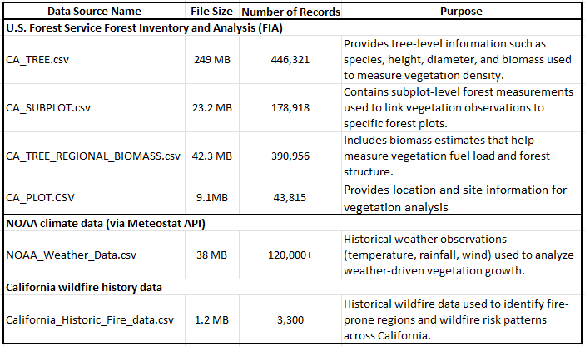
Some datasets contain thousands of records, so cloud storage is required to handle large file sizes efficiently. All datasets will be stored in Amazon S3, which will act as the project’s data lake. The datasets will be downloaded from their original sources and manually uploaded into an S3 bucket. The files will be organized into folders based on the data source.
One potential risk is that datasets from different sources have different formats, geographic identifiers, or missing values. These issues will be addressed during the data exploration and preprocessing phases through data cleaning, normalization of variables, and validation of key fields.
All datasets used in this project are stored in Amazon S3, which acts as the central storage for the data pipeline. The datasets are organized in the bucket s3://vegetation-risk-ml, with folders such as raw/forest, raw/fire, and raw/weather for the original datasets.
The data is loaded into the analysis environment using AWS SageMaker Studio notebooks. SageMaker connects to S3 using the Python boto3 library, which allows the files to be read directly into Pandas DataFrames for analysis and processing.
SageMaker was selected because it provides a cloud-based data science environment that integrates easily with other AWS services, such as S3 and Athena. Other tools like Apache Spark or AWS Glue were not considered because the dataset size can be efficiently processed using Pandas in SageMaker notebooks.
Data Exploration
During the initial exploration phase, the goal is to understand the structure, quality, and usefulness of the datasets before building machine learning models. This step helps identify potential data issues, missing values, or bias that could affect model performance. Statistical summaries and visualizations are used to study variable distributions, detect outliers, examine relationships between variables, and explore geographic patterns using latitude and longitude.
The datasets contain a mix of numeric, categorical, and temporal variables, including continuous environmental measurements, categorical species codes, and timestamp fields used for temporal analysis.
The wildfire dataset contains 3,372 records and 23 columns. Wildfire information includes incident_acres_burned, incident_latitude, incident_longitude, incident_date_created, and incident_county.
The forest vegetation dataset, created by merging the tree, subplot, and biomass tables, contains 1,687,167 records and 11 columns. Important variables in the forest dataset include forest attributes such as DIA (tree diameter), HT (tree height), SPCD (tree species code), STATUSCD (tree status), SLOPE, ASPECT, REGIONAL_DRYBIOT, and REGIONAL_DRYBIOM.
The weather dataset includes daily observations from multiple stations across California and contains key variables such as tavg (average temperature), tmin, tmax, prcp (precipitation), wspd (wind speed), atmospheric pressure, and station.
These variables represent environmental conditions that influence vegetation growth and wildfire risk.
Data Quality Checks
Several data quality checks are performed to ensure the reliability of the datasets. Missing values and duplicate records are checked. For example, the wildfire dataset contains some missing values in incident_administrative_unit, incident_acres_burned, and incident_containment, but no duplicate records were found. The meaning of missing values is also considered during exploration. For example, missing precipitation values may represent days without rainfall, while missing administrative unit values may indicate incomplete metadata. Similar checks are performed on the forest and weather datasets.
Unrealistic values, such as negative tree measurements or extreme temperatures, are examined. Geographic coordinates are also validated to ensure they fall within California boundaries (longitude −125 to −114 and latitude 32 to 42). Additional plausibility checks confirm that values fall within reasonable ranges. For example, tree diameter and height must be positive, and precipitation values should not be negative. Large wildfire sizes and biomass values are reviewed to determine whether they represent real events or data entry errors. In most cases, large wildfire sizes reflect real extreme wildfire events.
Exploratory Data Analysis
The exploration phase also analyzed variable distributions and relationships between environmental variables using visualization libraries like Seaborn and Matplotlib.
A pairplot of weather variables (tavg, prcp, pres, and wspd) is used to examine their distribution and relationships across weather stations ( Figure 1). The results show that temperature and pressure are approximately normally distributed, while precipitation shows a right-skewed distribution.
Figure 1:
Distribution and Relationship of Weather Variables
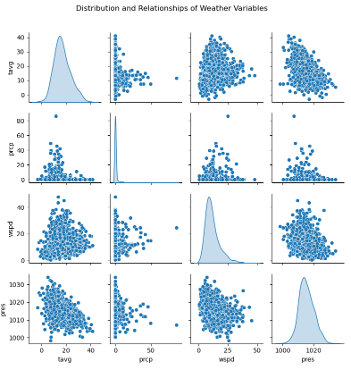
A histogram of the log-transformed wildfire size (incident_acres_burned) is used to study wildfire size distribution, as shown in Figure 2. The results show a highly right-skewed pattern, where most fires burn small areas while a small number of fires burn extremely large areas.
Figure 2:
Distribution of Wildfire Size
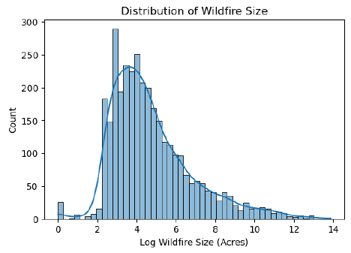

The correlation heatmap in Figure 3 shows that tree diameter and tree height are positively related to vegetation biomass, meaning areas with larger trees tend to have higher fuel loads. This is relevant for tree trim prioritization because areas with larger trees and higher biomass may need more vegetation management to reduce wildfire risk.
Figure 3:
Correlation between forest structure and biomass variable
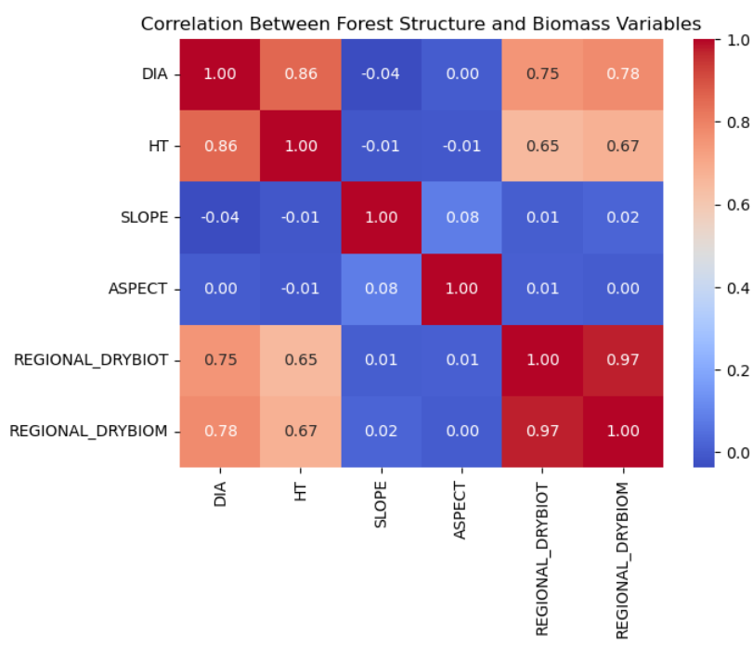
Finally, geographic coverage is analyzed using latitude and longitude coordinates. The results show that Northern California experiences frequent wildfire events, while Southern California often experiences larger fires due to dry environmental conditions. The Central Valley generally has fewer fires because vegetation density is lower. The number of wildfire incidents was analyzed across different months in California to understand seasonal patterns. The results show that July and August have the highest number of wildfire incidents, which aligns with the hot and dry summer conditions that increase wildfire risk.
These spatial patterns help identify high-risk vegetation areas where vegetation management actions, such as tree trimming, may help reduce wildfire risk.
Data Preparation
Before merging the datasets, each dataset is cleaned separately to remove errors and ensure consistency. This step is very important because poor-quality data can lead to incorrect predictions.
Data Scrubbing
For the forest dataset, only relevant columns such as DIA (tree diameter), HT (tree height), SLOPE, REGIONAL_DRYBIOT (biomass), and location variables (LAT, LON, COUNTYCD) are kept. Unnecessary columns are removed to reduce noise and improve performance. Duplicate records were removed to ensure each tree appeared only once in the dataset. To fill missing values in the REGIONAL_DRYBIOT column, the median is used because biomass data are skewed and may contain extreme outliers. Unrealistic values, such as trees with zero or negative diameter or height, were removed, keeping only trees with positive diameter and height values. Finally, all remaining trees that had valid coordinates within California's boundaries were verified.
For the fire dataset, the focus was to ensure only meaningful fire incidents were included. Fires with coordinates outside California were removed, which are latitudes between 32 and 42 degrees north and longitudes between -124 and -114 degrees west. Fires with missing coordinates were also removed since we needed location data for spatial matching. Fires that burned zero acres were also removed because they don't represent significant fire events. The date column was converted to a proper datetime format, and any records with missing county information were removed.
For weather data, missing rainfall values with zero were kept since no rain is a valid measurement. Missing wind speed was filled with the median value. Unrealistic temperatures that fell outside California's possible range were removed. Any remaining missing temperature values were filled using the average of the minimum and maximum temperatures, which was then dropped as tmax and tmin were highly correlated to tavg.
After cleaning, all datasets are stored back in S3 in the processed folder as forest_cleaned, weather_cleaned, and fire_cleaned. This ensures that only high-quality data is used for further steps.
Data Merging Using Athena
Once the data is cleaned, the next step is to merge the datasets into a single table. This is done using Amazon Athena. Athena is used because it can handle large-scale joins efficiently without loading data into memory.
In this project, the forest dataset is used as the base table. Fire incidents were aggregated using spatial grid buckets by rounding latitude and longitude values. This approach captures localized fire activity patterns without relying on administrative boundaries. By grouping fire data into these spatial grids, a compact representation of fire history is created for each geographic area. This allows each forest plot to be matched with nearby fire activity based on spatial proximity, ensuring that the model learns location-specific wildfire risk patterns.
The weather data was aggregated by station and month to capture average temperature, rainfall, and wind conditions over time. This approach ensures that seasonal weather patterns are preserved while reducing data size for efficient processing.
The forest dataset was then matched with fire data using spatial proximity. Fire incidents were grouped into spatial grid buckets based on rounded latitude and longitude values. For each forest plot, the distance to nearby fire grid points was calculated within a defined buffer, and a row number function was used to select only the closest match. This ensures that each forest plot is associated with the most relevant nearby fire activity.
Similarly, forest plots were matched with weather data using a spatial distance-based join. Each forest location was linked to the nearest weather station within a defined geographic range. This created a unified dataset where every tree record includes localized fire history and weather conditions, enabling accurate vegetation risk modeling.
The dataset contained approximately 243,820 rows, each representing an individual tree with its associated fire history and weather data. Each row includes tree characteristics like diameter, height, slope, and biomass; fire features like count, maximum size, average size, and years since last fire; weather features like temperature, rainfall, and wind speed; and distance measurements showing how far each plot is from fire incidents and weather stations.
The final result is a unified feature table (vegetation_risk_dataset) stored in S3 in Parquet format. This table, along with feature-engineered variables, becomes the main dataset used for machine learning.
Feature Engineering
Feature engineering was performed to create meaningful variables that help the model understand wildfire risk and vegetation conditions.
Fuel moisture risk: This feature combines temperature and rainfall. High temperatures and low rainfall create very dry vegetation, which increases fire risk. It helps identify areas that are highly flammable and need priority trimming.
Fire recurrence: This represents how frequently fires occur in a region. Areas with repeated fires are more likely to experience future fires, so this helps identify locations that require frequent monitoring and trimming.
Fuel load: This measures how much burnable material is present by combining tree size and biomass. Larger and denser vegetation increases fire intensity, so these areas become a high priority for trimming.
Seasonal patterns: Fire risk is higher during certain months, especially summer and early fall. Capturing this helps plan trimming schedules based on high-risk seasons.
Target Variable Creation
The target variable trim_priority was created using a wildfire risk score based on fuel load, fuel moisture risk, and fire recurrence. This score represents overall fire risk and was divided into three equal groups (Low, Medium, High) using quantiles. This creates a balanced and meaningful target for prioritizing tree trimming.
Feature Transformation
The target variable trim_priority, which contains categories Low, Medium, and High, was encoded into numerical values as Low = 0, Medium = 1, and High = 2 using label encoding. This was done because machine learning models require numerical input and cannot directly process text-based categories. Encoding the target variable into numbers allows the model to learn patterns and correctly classify vegetation risk levels for tree trimming prioritization.
Handling Skewed Distributions
Many of our features have skewed distributions. Fire counts and fire sizes tend to have many small values and a few extremely large values. Log transformations were applied to these features to make their distributions more normal, which helps machine learning models perform better.
Feature Selection
Features that directly influence wildfire risk and vegetation conditions were selected for training.
Vegetation features: (dia, ht, slope, regional_drybiot) These represent tree size and fuel load
Fire features: fire_recurrence, log_fire_size, seasonal features.These represent fire frequency and severity.
Weather features: avg_temp, avg_rain, avg_wind, fuel_moisture_risk ,represent dryness and fire conditions
Features like lat and lon were excluded to avoid overfitting. These selected features help the model learn patterns related to fuel availability, fire history, and environmental conditions, supporting accurate tree trimming prioritization.
Balancing the Dataset:
The dataset is imbalanced, with more Low-risk samples compared to High-risk. To address this, stratified sampling was used during dataset splitting to maintain the same class distribution across all sets. This helps ensure that the model learns patterns from all classes and improves performance on minority classes.
Dataset Splitting
The dataset is split into training (70%), validation (15%), and test (15%) sets. Stratification ensures equal distribution of Low, Medium, and High classes across all sets. This helps in proper model training, hyperparameter tuning, and final evaluation.
Model Training Approach Using SageMaker Built-In Algorithm
In this project, the model was developed using the SageMaker built-in algorithm. This approach was selected because it provides a strong balance between simplicity, scalability, and performs well for structured data.
The dataset consists of environmental, vegetation, and wildfire-related features stored in Amazon S3. Using the built-in approach allows seamless integration with S3, enabling direct data loading, training, and model output storage within the same system. This makes the workflow simpler, faster, and easier to reproduce in the future.
Another key advantage is that the built-in approach allows direct configuration of hyperparameters without requiring custom training scripts or environment setup. This reduces development complexity and makes the training process more efficient.
Overall, this approach ensures that the model is easy to train, scalable for large datasets, and fully integrated into a production-ready cloud workflow.
XGBoost Algorithm and Business Application
The algorithm used in this project is XGBoost, a tree-based model that works well with structured data. It was chosen because vegetation risk depends on multiple factors like biomass, temperature, rainfall, and fire history, which interact in complex ways. XGBoost can learn these patterns effectively and provide accurate predictions.
The problem is treated as a classification task with three categories: Low, Medium, and High risk. These categories directly support the business goal of prioritizing vegetation trimming, ensuring that high-risk areas are addressed first.
Since no labeled dataset was available, a risk score was created using domain knowledge, allowing the model to learn meaningful patterns. The model does not predict future fires but identifies areas that are likely to become risky if not managed.
By doing so, the model directly addresses the core business question: which areas should be prioritized for trimming now to reduce future wildfire exposure? .This supports proactive vegetation management and helps reduce wildfire risk while improving resource allocation.
Hyperparameters and Their Impact
Several hyperparameters were configured to ensure that the model learns effectively while avoiding overfitting.
The objective function used is multi:softprob, which allows the model to output probabilities for each class. This is important because it enables the calculation of a continuous risk score, which can be used to rank locations by priority.
The number of classes (num_class = 3) matches the three risk levels, ensuring the model aligns with the business requirement.
The learning rate (eta = 0.1) controls how quickly the model learns. A moderate value was chosen to ensure stable learning without overfitting.
The maximum depth (max_depth = 5) limits the complexity of each decision tree. This helps the model capture important relationships while avoiding noise.
To improve generalization, subsample and colsample_bytree were both set to 0.8. This means the model uses only a portion of the data and features for each tree, which reduces overfitting and improves robustness.
Additional parameters include:
- min_child_weight = 5
- gamma = 1
- regularization (alpha)
This helps control tree growth and prevent overfitting.
The number of boosting rounds (num_round = 150) was selected to balance performance and training time.
Together, these parameters ensure that the model is accurate, stable, and generalizable.
This is critical because the model needs to perform well on new, unseen locations.
Instance Size and Training Setup
The model was trained on a single ml.m5.large instance in SageMaker. This choice was based on a few important factors.
First, with about 243,000 records and 12 features, the data fits easily in one instance, so there was no need for multiple machines. Using more instances would increase cost without much benefit.
Second, the algorithm XGBoost works well on CPU, so using a GPU was not needed and would only increase cost.
Third, training time was checked. The model finished training in about 185 seconds, showing that the instance was sufficient.
Finally, this setup provides a good balance between performance and cost. CloudWatch was used to monitor usage, and the system can be scaled in the future if needed.
Model Evaluation and Results
The model was evaluated using a stratified 70/15/15 train-validation-test split to ensure reliable and unbiased performance measurement. Stratified splitting was used to maintain equal representation of Low, Medium, and High risk classes across all datasets, preventing misleading results and ensuring that the model performs consistently on unseen data.
Table 2
Classification Performance Metrics
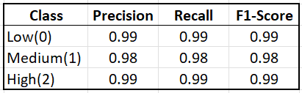
Multiple evaluation metrics were used, including accuracy, precision, recall, F1-score, and a confusion matrix, as shown in Table 2 and Figure 4. These metrics were selected to reflect not only overall model performance but also how well the model performs for each risk category.
The model achieved an overall accuracy of approximately 98.82%, with precision and recall values close to 0.98–0.99 across all classes. However, accuracy alone is not sufficient for this problem. In the context of vegetation risk, the most important metric is recall for the High-risk class, because failing to identify a high-risk area could lead to wildfire damage. The model achieved 99% recall for high-risk areas, meaning almost all critical locations are correctly identified.
Figure 4
Confusion Matrix
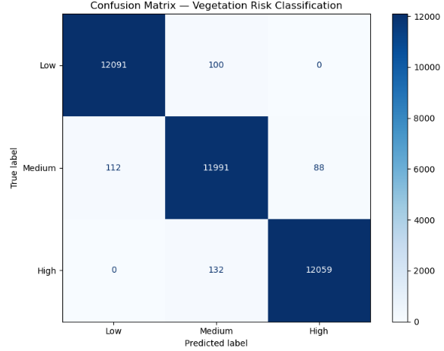
At the same time, precision is also important to ensure resources are used efficiently. A low precision would result in unnecessary trimming in low-risk areas. With 99% precision for high-risk predictions, the model ensures that flagged areas are truly high risk, supporting effective allocation of crews and preventing resources from being wasted on unnecessary trimming.
The confusion matrix (shown in Figure 1) further confirms the model’s effectiveness. Most predictions are concentrated along the diagonal, indicating that the majority of vegetation risk levels are correctly classified.
For the Low-risk class, 12,091 instances were correctly predicted, with only 100 misclassified as Medium. For the Medium-risk class, 11,991 instances were correctly classified, with small errors into Low (112) and High (88). For the High-risk class, 12,059 instances were correctly identified, with only 132 misclassified as Medium and none as Low. Importantly, there are no cases where high-risk areas are classified as low-risk, which is critical for wildfire prevention.
By focusing on metrics like recall and precision for high-risk areas, the model directly supports the key objective of identifying which locations should be prioritized for vegetation trimming to reduce wildfire risk.
Feature Importance
The model identifies several key features driving vegetation risk predictions, as shown in Figure 5:
Figure 5
Feature Importance
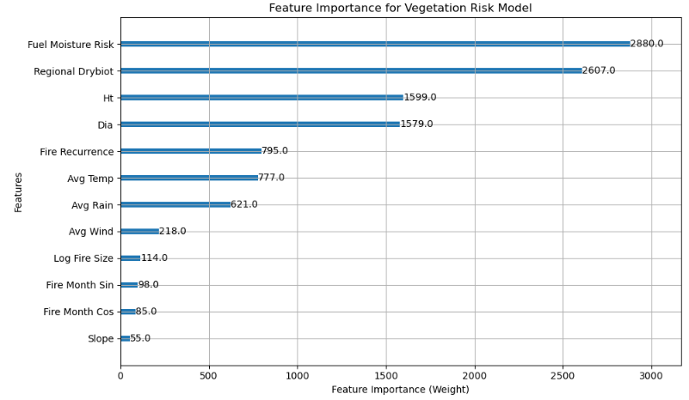
- Fuel Moisture Risk (2880) - Strongest indicator of vegetation dryness
- Regional Biomass (2607) - Represents available fuel load
- Tree Height (1599) and Diameter (1579) - indicate vegetation size and density
- Fire Recurrence (795) - Captures historical fire exposure
- Average Temperature (777) and Rainfall (621) - Reflect environmental conditions
- Average Wind (218) - Influences fire spread potential
- Log Fire Size (114) - Represents past fire severity
- Fire Seasonality (sin: 98, cos: 85) - Captures seasonal patterns
- Slope (55) - Steeper land helps fire spread faster
Overall, the model highlights environmental dryness, fuel availability, and fire history as the primary drivers of vegetation risk. This aligns with real-world wildfire behavior and confirms that the model is both interpretable and practically meaningful for decision-making.
Batch Inference
After training the model, predictions were generated using SageMaker Batch Transform, which allows running predictions on the entire dataset at once without creating a real-time endpoint.
Batch inference was used because the dataset is large (about 243,820 vegetation locations). Running predictions one by one in real time would be slow and unnecessary. Instead, Batch Transform processes all data in bulk and saves the results directly to Amazon S3 (in folders like batch-output/ and predictions/).
Batch Transform integrates directly with the trained XGBoost model artifact (model.tar.gz) stored in S3, making it easy to move from training to prediction within the same system.
Figure 6:
SageMaker Batch Transform Output and Model Artifact in Amazon S3
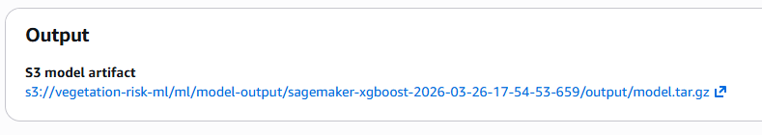
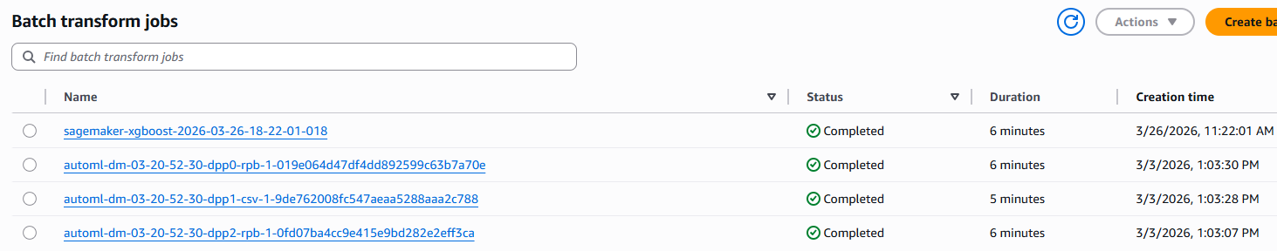

This approach provides several key advantages. It enables scalable processing of large datasets, allowing vegetation risk scoring across over 243,000 locations efficiently. It is also cost-effective, as it eliminates the need to maintain a real-time endpoint. Additionally, the process is automation-ready, meaning it can be scheduled to run periodically (e.g., daily or weekly updates).
From a business perspective, this supports full-region vegetation risk assessment, enables regular updates for decision-makers, and allows seamless integration with dashboards. As a result, the system can consistently identify which areas should be prioritized for trimming at scale.
CloudWatch Monitoring
Amazon CloudWatch was used to monitor the training process and track model performance across boosting rounds. From Figure 7, we can see that both log loss and error decrease steadily, which means the model is learning correctly. The validation error dropped from about 11% to 1.13%, and log loss reduced from about 1.0 to 0.053.
By the final stage, the model achieved:
- Train mlogloss = 0.04897
- Train error = 0.00814 (0.81%)
- Validation mlogloss = 0.05296
- Validation error = 0.01135 (1.13%)
Figure 7
XGBoost Learning Curves for Training and Validation
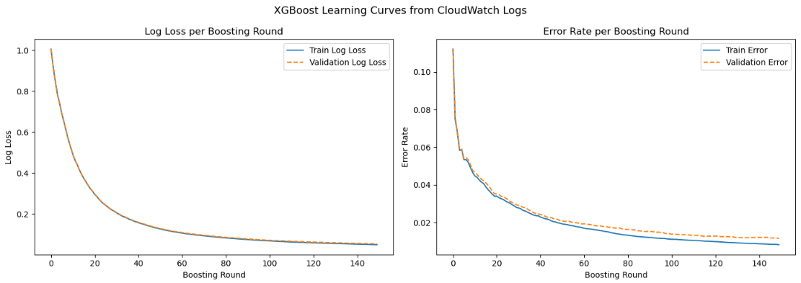
The difference between training and validation error is very small (about 0.3%), which shows that the model is not overfitting and performs well on new data.
These results demonstrate that the model has learned meaningful patterns from the data and can produce accurate, stable, and reliable predictions. From a business perspective, this ensures the model can reliably identify high-risk vegetation areas, helping decision-makers prioritize trimming and reduce wildfire risk with confidence.
Visualization and Interactive Dashboard
The model predictions were integrated into an interactive dashboard built using Python Dash, enabling visualization of vegetation risk across different geographic locations.
The dashboard displays key outputs such as:
· Vegetation risk levels (Low, Medium, High)
· Risk scores for each location
· Geographic distribution using latitude and longitude
Figure 8
Snippet of Interactive Dashboard Built Using Plotly Dash with Model Predictions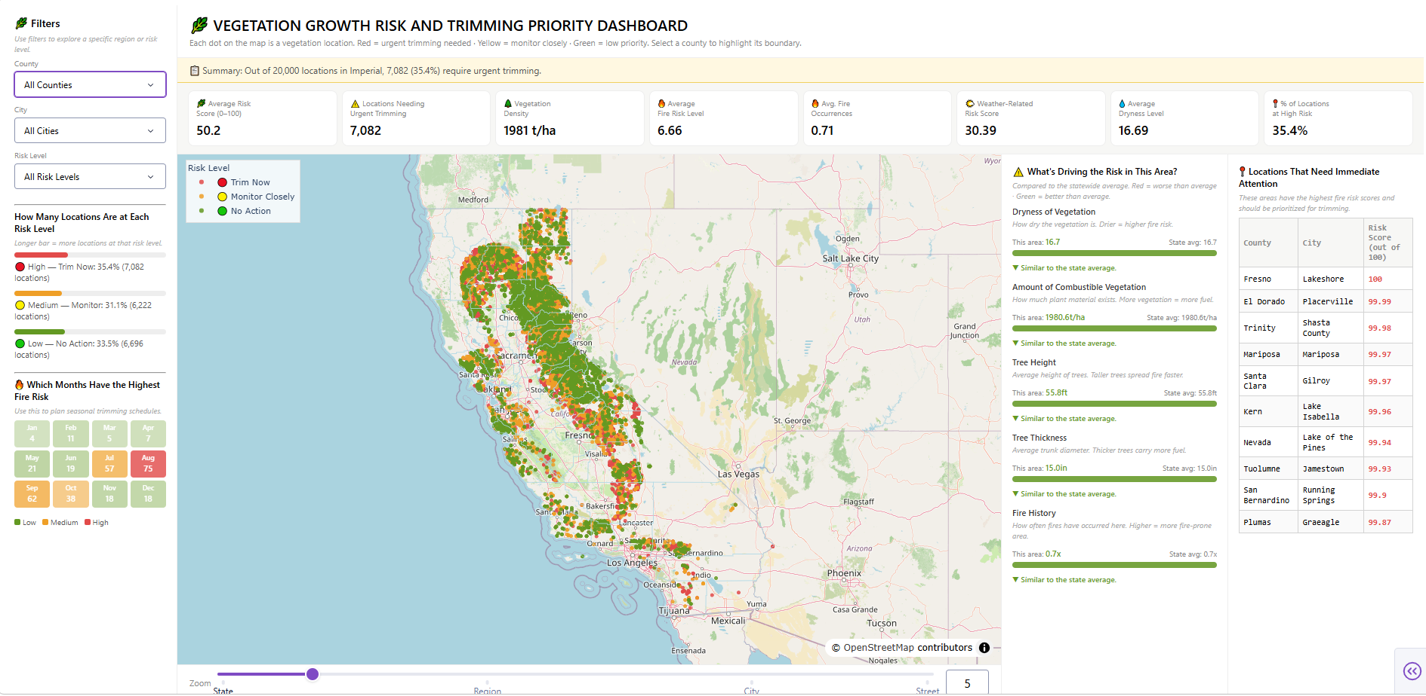
Users can interact with the dashboard by filtering and exploring different regions, allowing them to easily identify high-risk areas that require immediate attention.
This visualization layer transforms model predictions into actionable insights, making it easier for stakeholders to understand the results and make informed decisions. Instead of analyzing raw data, decision-makers can directly view and prioritize areas for vegetation trimming.
Measuring Impact
The success of this project will be evaluated using measurable metrics aligned with the goal of predicting vegetation growth risk and supporting proactive vegetation management.
- Model Performance -The machine learning model should achieve at least 80% accuracy and an F1-score above 0.75 when predicting vegetation trimming priority levels.
- High Vegetation Risk Detection Rate – This metric measures how well the model identifies high-risk vegetation areas using factors such as vegetation density, biomass, temperature, precipitation, and wildfire history. The goal is to correctly identify 70–80% of regions that previously experienced large wildfires as high-risk areas.
- Geographic Coverage Rate -This metric measures how many regions can be analyzed using the combined forestry, wildfire, and weather datasets. By integrating these datasets, the project aims to achieve 85–90% coverage of forested regions in California, ensuring that most areas can be evaluated for vegetation growth risk.
- Vegetation Risk Visualization Availability – This metric measures the percentage of regions with generated vegetation risk scores and dashboard visualizations. The goal is to provide visual risk insights for at least 90% of analyzed regions to help utilities prioritize tree trimming.
Security Checklist, Privacy, and Other Risks
This project does not store or process Protected Health Information (PHI) or Personally Identifiable Information (PII). All datasets used are environmental datasets collected from public government sources.
This project does not involve financial transactions or payment processing.
The application reads and writes data to the S3 bucket:s3://vegetation-risk-ml. The bucket contains separate folders for raw datasets, processed datasets, and Athena query results to maintain clear data organization.
Several forms of data bias may exist in the datasets, including spatial bias if some regions have more observations than others, and temporal bias if certain years contain more wildfire data. Measurement bias may also occur because different agencies collect environmental data using different methods. These biases will be examined during data exploration to reduce the risk of misleading results.
The primary ethical consideration in this project is that the model should serve as a decision-support tool, rather than a fully automated decision system. This ensures that environmental experts review vegetation management recommendations before any actions are taken.
Future Enhancements
Based on the current model and its results, there are several important improvements that can make the system more accurate, practical, and useful for real-world decision-making.
1. Implement Real-Time and Time-Based Predictions
The current system uses batch inference to generate predictions for large datasets, which is effective for overall planning. However, it does not support instant decision-making when conditions change suddenly, and it also shows risk only at a single point in time without capturing how risk evolves over time.
A key improvement would be to deploy the model as a real-time endpoint while also incorporating time-based features such as trends and seasonality. This would allow users to get immediate risk predictions for specific locations when needed, such as during extreme weather events or emergency situations, while also understanding how risk may change due to weather or seasonal patterns.
Some areas may become more dangerous quickly due to changing conditions, and time-based modeling can help identify locations that are becoming risky, not just those that are already high risk. From a business perspective, this enables faster response to high-risk conditions and supports proactive planning, helping teams take action immediately and prevent problems before they occur.
2. Integration of Additional Data Source
The accuracy of the model can be improved by adding more data sources such as satellite imagery, vegetation health (NDVI), soil moisture, and infrastructure data (e.g., power lines and population density). Currently, the model relies on historical averages, which do not fully reflect current conditions.
These additional inputs provide a more complete and updated understanding of vegetation and surrounding risk factors. For example, satellite data shows current vegetation health, while infrastructure data highlights areas where damage could have a greater impact. This improves overall prediction quality and helps prioritize areas that require attention.
3. Enabling Faster Response with Automated Alerts
Automated alerts can be added to make the system more responsive and useful in real-world situations. Once the model generates risk scores, we can set a threshold, for example, when the risk score goes above a certain level. When this condition is met, the system can automatically trigger an alert.
Technically, this can be done using AWS services. The model outputs can be monitored using Amazon CloudWatch, where rules can be created to detect high-risk values. These rules can then trigger notifications through Amazon SNS, which delivers alerts via email or SMS to field teams. This setup allows teams to respond immediately to high-risk conditions instead of waiting for batch updates. Overall, automated alerts improve response time, support real-time decision-making, and make the system more practical and efficient for daily operations.
Conclusion
This project successfully developed a scalable vegetation risk prioritization system using XGBoost on structured environmental and wildfire data. By engineering a composite risk score in the absence of labeled data, the model was able to classify vegetation into Low, Medium, and High risk categories and support data-driven decision-making.
The model achieved an overall accuracy of approximately 98.8%, exceeding the target performance metrics, with consistently high precision and recall across all classes. The confusion matrix further confirms strong performance, with most predictions correctly classified and no cases where high-risk areas were misclassified as low-risk. This is especially important for wildfire prevention, as it ensures critical areas are not overlooked.
The system also shows strong geographic coverage, analyzing vegetation risk across over 243,000 locations spanning 57 out of 58 counties in California (approximately 98% coverage). This exceeds the initial target of 85–90% coverage and ensures that most regions can be evaluated effectively.
From a business perspective, the model effectively addresses the key question:
“Which areas should be prioritized for trimming now to prevent future wildfire risk?”
With 99% recall for high-risk areas, the system identifies nearly all critical locations, while high precision ensures efficient use of resources. The integration of SageMaker Batch Transform enables large-scale prediction across 243000 locations, making the solution practical and scalable for real-world deployment.
Although the model is a risk assessment system rather than a time-based predictive model, it provides forward-looking insights by identifying areas likely to become hazardous if left unmanaged. This supports proactive vegetation management and helps reduce wildfire risk.
Overall, the solution demonstrates how machine learning can transform environmental data into actionable insights for safety, efficiency, and operational planning.

Git Repository link: https://github.com/SheshmaJ/ADS-508-Final-Project.git

References
CAL FIRE. (2023). Top 20 most destructive California wildfires. https://www.fire.ca.gov
National Oceanic and Atmospheric Administration. (2023). Billion-dollar weather and climate disasters. https://www.ncei.noaa.gov
Amazon Web Services, Inc. (n.d.). Amazon CloudWatch: User guide.
https://docs.aws.amazon.com/AmazonCloudWatch/latest/monitoring/WhatIsCloudWatch.html
U.S. Forest Service. (n.d.). Forest Inventory and Analysis (FIA).
https://www.fia.fs.usda.gov/tools-data/
California Department of Forestry and Fire Protection (CAL FIRE). (n.d.). California wildfire incident data. https://www.fire.ca.gov/incidents
Meteostat. (n.d.). Meteostat weather and climate data. https://meteostat.net
National Centers for Environmental Information (NCEI). (n.d.). Global Historical Climatology Network daily (GHCN-D). https://www.ncei.noaa.gov/products/land-based-station/global-historical-climatology-network-daily
OpenAI. (2026). ChatGPT (April 8 version) [Large language model]. https://chat.openai.com/

